**1**.In what modes should the PdfFileReader() and PdfFileWriter() File objects will be opened?

**Ans:**  For **PdfFileReader()** file objects should be opened in **rb ->** read binary mode, Whereas for **PdfFileWriter()** file objects should be opened in **wb ->** write binary mode.

**2.** From a PdfFileReader object, how do you get a Page object for page 5?

**Ans**: PdfFileReader class provides a method called **getPage(page_no)** to get a page object.

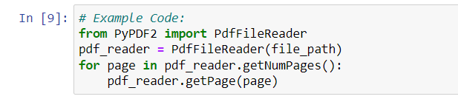

**3.** What PdfFileReader variable stores the number of pages in the PDF document?

**Ans:** **getNumPages()** method of **PdfFileReader** class stores the no pages in a PDF document

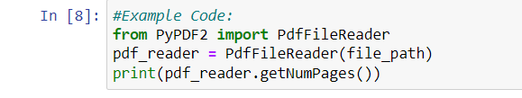

**4**. If a PdfFileReader object’s PDF is encrypted with the password swordfish, what must you do before you can obtain Page objects from it?

Ans: If a PdfFileReader object’s PDF is encrypted with the password swordfish and you're not aware of it. first read the Pdf using the PdfFileReader Class. PdfFileReader class provides a attribute called isEncrypted to check whether a pdf is encrypted or not.

**5**. What methods do you use to rotate a page?

Ans: PyPDF2 Package provides 2 methods to rotate a page:

1. rotateClockWise() -> For Clockwise rotation
2. rotateCounterClockWise() -> For Counter Clockwise rotation.

**6.** What is the difference between a Run object and a Paragraph object?

Ans:  The structure of a document is represented by three different data types in **python-Docx**. At the highest level, a Document object represents the entire document. The Document object contains a list of Paragraph objects for the paragraphs in the document.

**7.** How do you obtain a list of Paragraph objects for a Document object that’s stored in a variable named doc?

**Ans:** 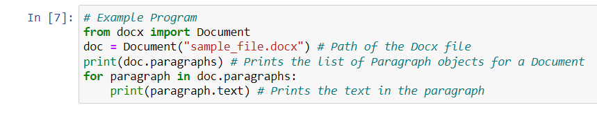

8. What type of object has bold, underline, italic, strike, and outline variables?

Ans:  **Run** object has bold, underline, italic, strike, and outline variables. The text in a Word document is more than just a string. It has font, size, color, and other styling information associated with it.

A style in Word is a collection of these attributes. A Run object is a contiguous run of text with the same style. A new Run object is needed whenever the text style changes.

9. What is the difference between False, True, and None for the bold variable?

Ans: 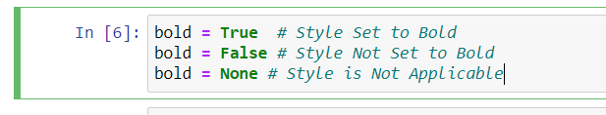

10. How do you create a Document object for a new Word document?

Ans: 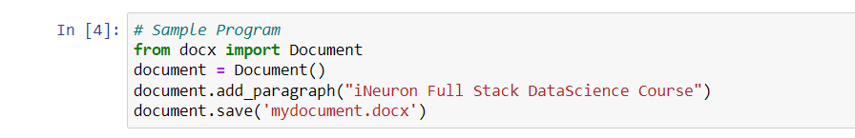

11. How do you add a paragraph with the text 'Hello, there!' to a Document object stored in a variable named doc?

Ans: 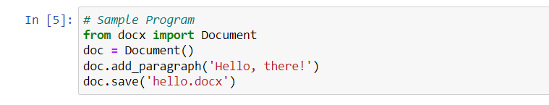

12. What integers represent the levels of headings available in Word documents?

Ans: The levels for a heading in a word document can be specified by using the **level** attribute inside the **add_heading** method. There are a total of 5 levels statring for 0 t0 4. where level 0 makes a headline with the horizontal line below the text, whereas the heading level 1 is the main heading. Similarly, the other headings are sub-heading with their's font-sizes in decreasing order.